Journal Entry (02/13/22 - 02/27/22)

02/13/22:

What is the problem: I am not familiar with this CAD software known as Autodesk TinkerCad which will be required for modeling our compartment .

Why: This is a problem because if I do not establish familiarity with the software, then I will be unable to create the compartment that is needed to house the hardware of our Keyboard Finger Position Display.

How: I plan on solving this by reviewing tutorials online to understand the tools that are in the software so that I can work on modeling our compartment. I plan to assess my progress by entering different logs.

Today, I learned some of the basic skills of Tinkercad such as how to place objects in the workspace and change the view of it through this tool known as View Cube that can rotate the camera. I also learned how to rotate objects and group them together to create one object (Ctrl + G) . In addition, I learned how to copy (Ctrl + C), duplicate, (Ctrl + D), align objects, and hide objects (Ctrl + H).

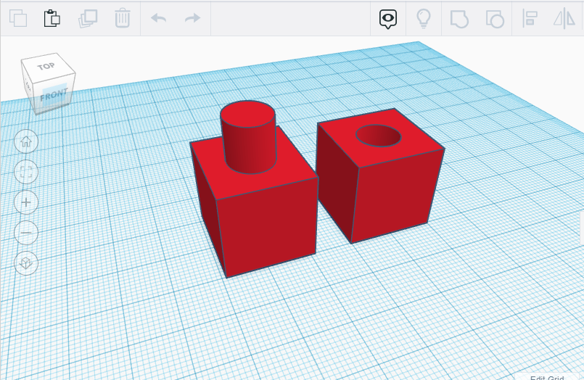

Grouping a cylinder and cube

02/15/22:

Today, I will learn how to create different objects such as a chess piece or glasses based on the lessons that are provided from the Autodesk TinkerCad website. These lessons will assist me in learning the process of how to create an object with multiple pieces from scratch along with additional tools. I learned how to dimension and scale objects in the workplane.

| Glasses | Chess Piece |
| --- | --- |

02/17/22:

Today, I created a table of all of our hardware’s dimensions. I will use this to determine how much space is available from our keyboard for our compartment.

List of Hardware for Keyboard Finger Position Display

| Hardware | Dimensions |
| --- | --- |
| TCA9548A I2C Multiplexer | 30.6mm x 17.6mm x 2.7mm / 1.2" x 0.7" x 0.1" |
| MPR121 Capacitive Touch Sensor | 33mm x 19mm x 2mm / 1.3" x .8" x .1" |
| Arduino Nano | 18 mm x 45 mm / 0.71” x 1.8” |
| 30 AWG Wire | Length: TBD |
| Space Available Inside Keyboard | TBD |

02/21/21

Today, I met with my team members Slate Jordan and Chase Williams to determine how much space is available from our new keyboard kit (Gateron Gk61). There were a few limitations such as the area that houses the battery and Bluetooth connected to the PCB board. There were also areas that looked like slots which needed to be larger in order to hold some of the capacitive touch sensors, Arduino Nano, and other hardware . We are planning to remove some of these slots to create more space. I could not get any measurements as planned which is problematic for the design of a possible compartment.

| GEEK GK61 | Description |
| --- | --- |
|  | Keyboard GK61X with battery |
|  | Keyboard GK61X without battery  NOTE: Obviously, there is a lot of space without the battery included, but it is still needed which we will have to deal with. |
|  | We also considered placing our hardware in these slots that are in the keyboard case without a compartment, but these slots are not large enough. |

02/25/21:

Today, I decided to use TinkerCad to flush out my ideas of a modified design of what the compartment would look like based on my initial sketches for practices and progress and application.

